AIS AtoN installation in the Antarctic by the Argentine Republic (2011-2023 Programme)

*English version provided by the author*

**AIS AtoN installation in the Antarctic by the Argentine Republic**

**(2011 – 2023 Programme)**

*Information document submitted by the Argentine Republic*

**Summary**

Argentine Republic hereby informs the Consultative Parties and the Antarctic community as a whole about the works on the *Automatic Identification System (AIS)* developed during the last years in the Antarctic Continent.

Consultative Parties are invited to become aware of the current situation and they together with tourist operators, who are IAATO members, are advised to issue reports for the AIS Aton optimization.

**INTRODUCTION**

In response to the exponential increase in navigation in the Antarctic and, with the aim of improving the safety of human life at sea and the protection of the marine environment, in December 2016 the Argentine Republic submitted to the IMO Sub-committee on Navigation, Communications and Search and Rescue (NCSR) its plan of study and tests with AIS Aton that began in 2011 in a joint work performed with the *Servicio de Hidrografía Naval*, private companies, the Antarctic National Command and the Joint Antarctic Patrol responsible for the logistics operations in the Argentine bases.

**DEVELOPMENT**

In order to update the submitted information on the AIS Aton installation in the Antarctic, its progress between the 2011/2012 and 2022/2023 Antarctic Summer Campaigns (ASCs) is set forth below in chronological order.

* During the 2011/2012 and 2012/201 ASCs an AIS AtoN was deployed in the Orcadas Station (LAT. 60° 44 S LON 044° 44 W), that enabled the generation of one Real AIS signal and four virtual signals to mark geographic features.

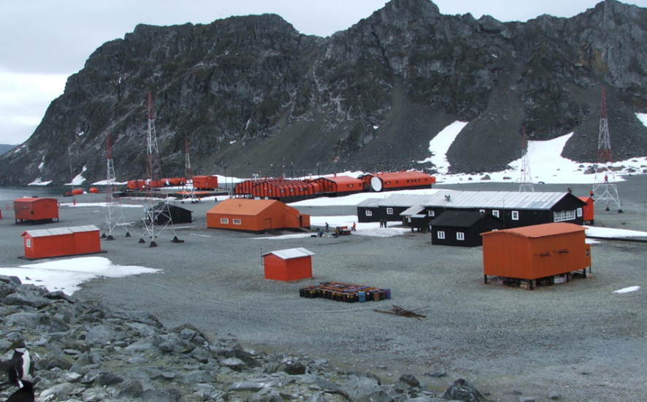

|  |  |  |  |  |  |
| --- | --- | --- | --- | --- | --- |
|  | Location | AtoN type | MMSI | Latitude | Longitude |
| 1. | **Estación Orcadas 1** | Real | 997011088. | 60°44´ S | 044° 44´ W |
| 2. | Montura Island | Virtual | 997016104. | 60° 36.75´ S | 044° 53,12´ W |
| 3. | Brisbane Islet | Virtual | 997016103. | 60° 37.68´ S | 045° 02,25´ W |
| 4. | Corbeta Islet | Virtual | 997016102. | 60° 40.75´ S | 044° 55,82´ W |
| 5. | Sörle Cape | Virtual | 997016101. | 60° 45.10´ S | 044° 58,62´ W |

* During the 2014/2015 ASC a second AIS AtoN equipment was deployed in the Orcadas Station, which enabled the generation of another real AIS and four additional virtual signals.

|  |  |  |  |  |  |
| --- | --- | --- | --- | --- | --- |
|  | Location | AtoN type | MMSI | Latitude | Longitude |
| 1. | **Estación Orcadas 2** | Real | 997011089. | 60°44.22´ S | 044° 44,30´ W |
| 2. | Wistrom Islet | Virtual | 997016105. | 60° 47.31´ S | 044° 45,50´ W |
| 3. | Burn Murdoch Cape | Virtual | 997016106. | 60° 48.87´ S | 044° 42,35´ W |
| 4. | Murray Islet | Virtual | 997016108. | 60° 46.50´ S | 044° 31,25´ W |
| 5. | Herdman Rock | Virtual | 997016107. | 60° 40.90´ S | 044° 19,95´ W |

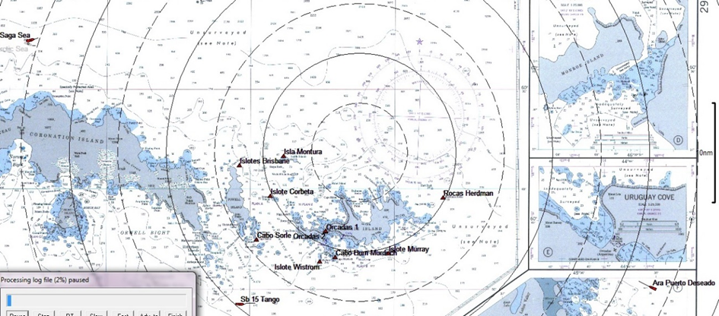

**CONFIGURATION OF TWO REAL AND VIRTUAL AIS AtoN**

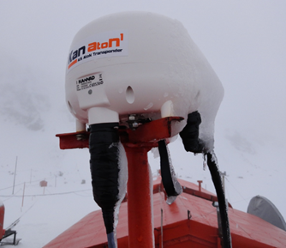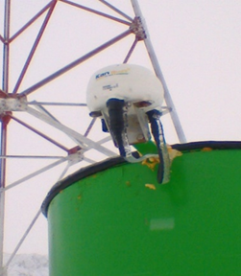

**ORCADAS UNO – ORCADAS DOS**

* 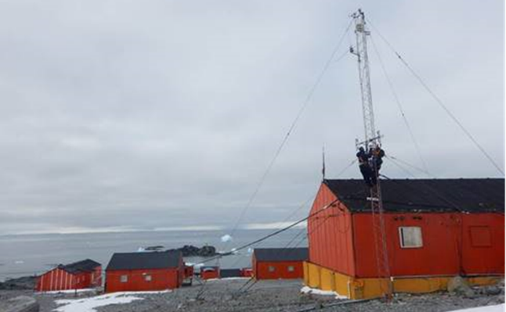During the 2015/2016 ASC an AIS AtoN station was deployed in the Esperanza Station (LAT.63° 23.5’ S LON 056° 59.4’ W), which enabled the generation of one real AIS signal, three virtual and one synthetic signal.

**ESPERANZA STATION**

|  |  |  |  |  |  |
| --- | --- | --- | --- | --- | --- |
|  | Location | AtoN type | MMSI | Latitude | Longitude |
| 1. | **Estación Esperanza** | Real | 997011091. | 63°23.90´ S | 056° 59,88´ W |
| 2. | Sheppard Point | Virtual | 997016109. | 63°22.55´ S | 056° 58,35´ W |
| 3. | Welchness Cape | Virtual | 997016110. | 63°29.10´ S | 056° 15.29´ W |
| 4. | Esperanza Lighthouse | Synthetic | 997011104. | 63°23.71´ S | 056° 58.52´ W |
| 5. | Kinnes Cape | Virtual | 997016112. | 63°22.50´ S | 056° 33.32´ W |

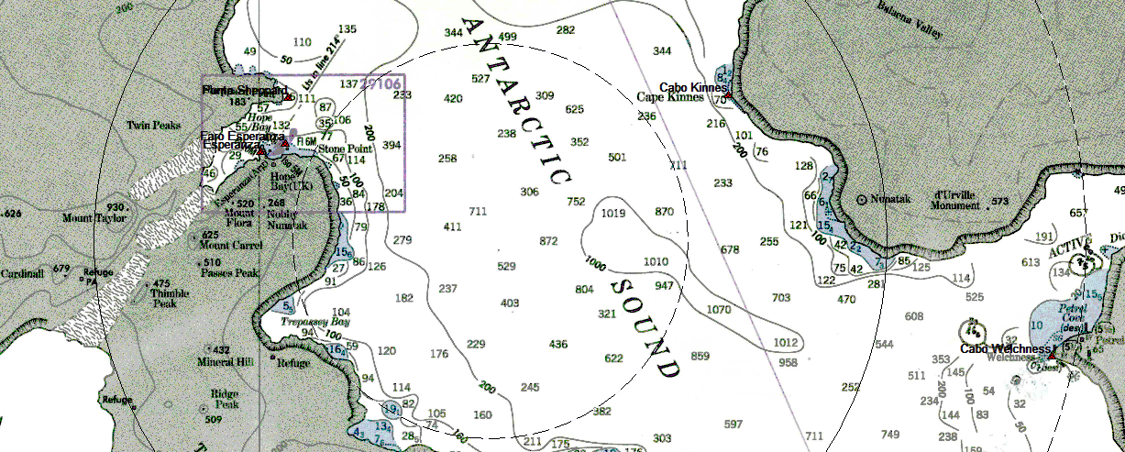

**CONFIGURATION OF ONE REAL, THREE VIRTUAL AND ONE SYNTHETIC AIS AtoN**

* During the 2016/2017 ASC two new AIS AtoN stations were installed, one of them at the CARLINI Station (LAT. 62° 14.2’ S LON 058° 40.1’ W) and another on DECEPCIÓN Station (LAT.62° 59’ S LON 060° 43’ W) generating each of them four virtual signals, which were timely informed through Navarea VI Navigational Warnings and the Notices to Mariners issued by the *Servicio de Hidrografía Naval* of the Argentine Republic.

**CARLINI STATION**

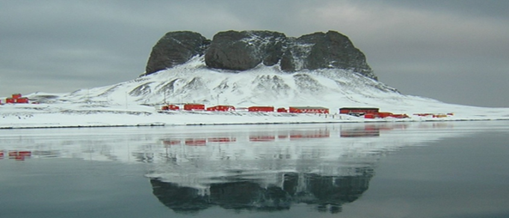

|  |  |  |  |  |  |
| --- | --- | --- | --- | --- | --- |
|  | Location | AtoN type | MMSI | Latitude | Longitude |
| 1. | **CARLINI STATION** | Real | 997011092. | 62° 14.24’ S | 058° 39,83’ W |
| 2. | Roca “M” | Virtual | 997016116. | 62° 15.62’ S | 058° 41,45’ W |
| 3. | Chanchito Rock | Virtual | 997016114. | 62° 18.50’ S | 058° 47,82’ W |
| 4. | Winship Point | Virtual | 997016115. | 62° 14.60’ S | 058° 43,67’ W |
| 5. | Stranger Point | Virtual | 997016113. | 62° 15.71’ S | 058° 37,00’ W |

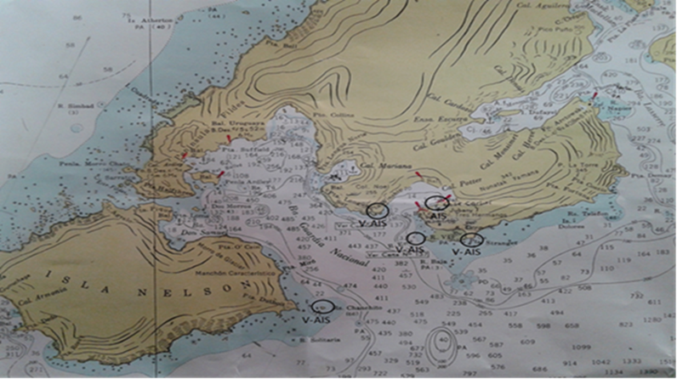

**DECEPCIÓN STATION**

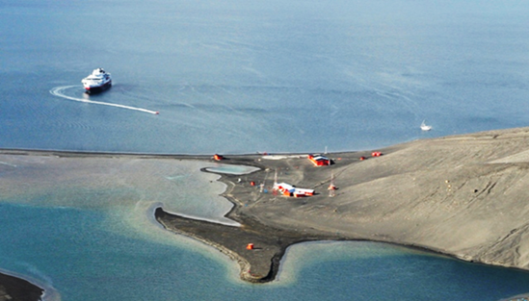

|  |  |  |  |  |  |
| --- | --- | --- | --- | --- | --- |
|  | Location | AtoN type | MMSI | Latitude | Longitude |
| 1. | **DECEPCION STATION** | Real | 997011093. | 62°58.60’ S | 060° 42,05’ W |
| 2. | Monolito | Virtual | 997016117. | 62° 59.52’ S | 060° 32,97’ W |
| 3. | Ravn Rock | Virtual | 997016120. | 62° 59.71’ S | 060° 33,32’ W |
| 4. | Entrada Point | Virtual | 997016118. | 62° 59.87’ S | 060° 33,28’ W |
| 5. | Balcarce Point | Virtual | 997016119. | 62° 59.56 S | 060° 33,54’ W |

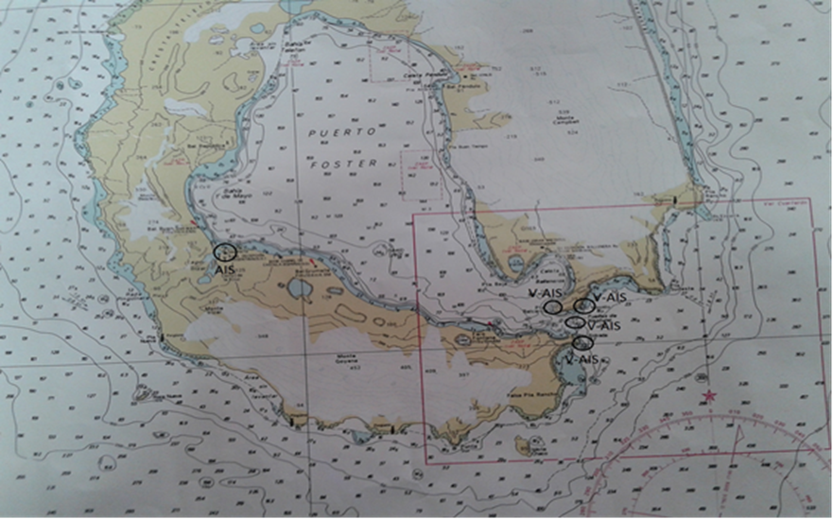

* During the 2017/2018 ASC two new AIS AtoN stations were deployed, one of them at the BROWN Base (LAT. 64° 54’ S LON 062° 12’ W) and another on SAN MARTIN Base (LAT. 68° 08’ S Longitude 067° 08’ W). The station at Brown Base generates one real and four virtual signals while the one at San Martin base generates one real signal and four synthetic ones, which were timely informed through NAVAREA VI Navigational Warnings and the Notices to Mariners issued by the Servicio de Hidrografía Naval of the Argentine Republic.

**BROWN STATION**

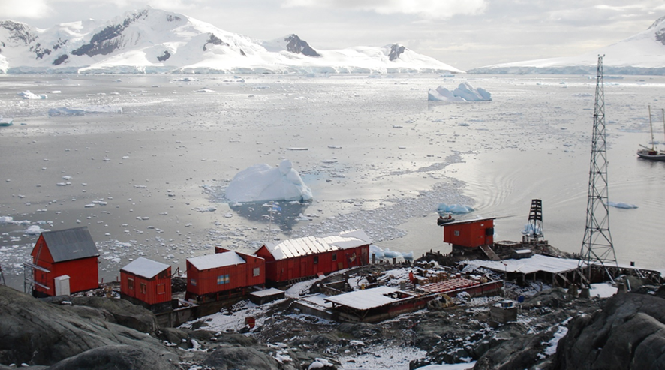

|  |  |  |  |  |  |
| --- | --- | --- | --- | --- | --- |
|  | Location | AtoN type | MMSI | Latitude | Longitude |
| 1. | **Brown Station** | Real | 997011095. | 64°53.72’ S | 062° 52,24’ W |
| 2. | Vieytes Point | Virtual | 997016128. | 64°53.72’ S | 062° 57,31’ W |
| 3. | Rondeau Point | Virtual | 997016127. | 64° 53.51’ S | 062° 56,02’ W |
| 4. | Laprida Point | Virtual | 997016124. | 64° 54.02’ S | 063° 04,58’ W |
| 5. | San Eladio Cape | Virtual | 997016125. | 64° 51.01’ S | 063° 07,16’ W |

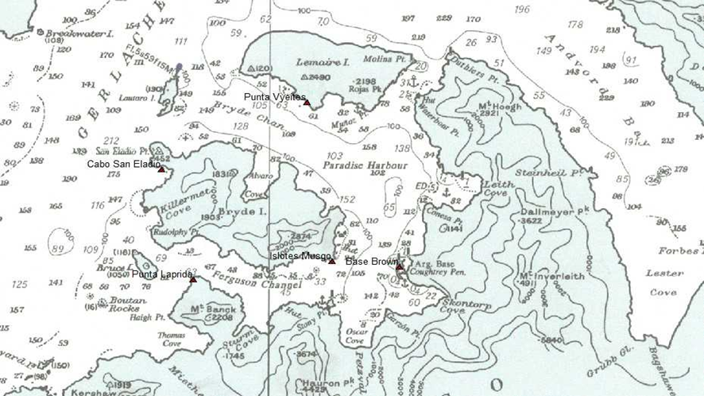

**SAN MARTÍN STATION**

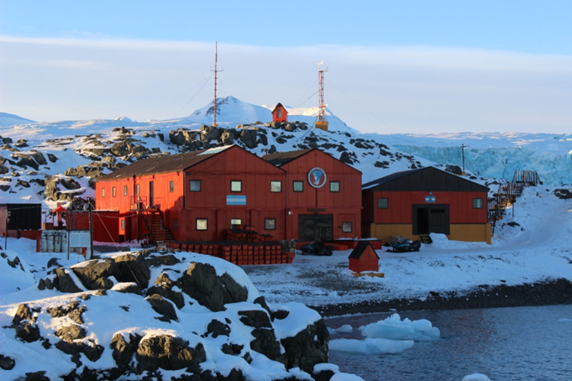

|  |  |  |  |  |  |
| --- | --- | --- | --- | --- | --- |
|  | Location | AtoN type | MMSI | Latitude | Longitude |
| 1. | **San Martín Station** | Real | 997011094. | 68°07.83’ S | 067° 06,17’ W |
| 2. | Lanusse Beacon | Synthetic | 997011102. | 68°12.98’ S | 066° 57,15’ W |
| 3. | Libertad Beacon | Synthetic | 997011101. | 68° 11.74’ S | 067° 09,30’ W |
| 4. | 22 de febrero Beacon | Synthetic | 997011100. | 68° 10.44’ S | 067° 15,63’ W |
| 5. | Garay Beacon | Synthetic | 997011103. | 68° 08.61’ S | 067° 03,87’ W |

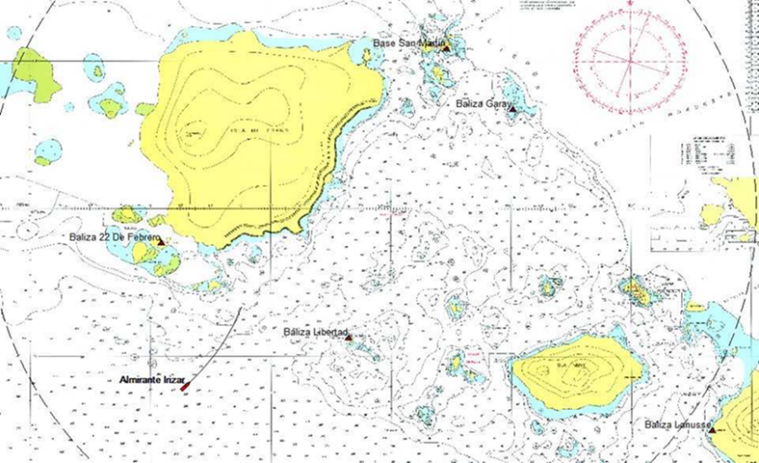

* During the 2018/2019 ASC an AIS AtoN was renewed at the ORCADAS Station (LAT. 60º 44’ S Longitude 044º 44’ W). In contrast to the previous one, this station generates one real signal and ten virtual ones, which were timely informed through Navarea VI Navigational Warnings and the Notices to Mariners issued by the *Servicio de Hidrografía Naval* of the Argentine Republic.

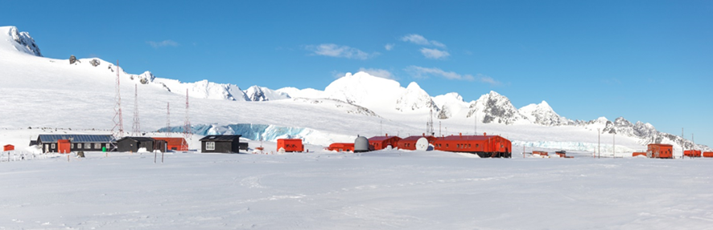

|  |  |  |  |  |  |
| --- | --- | --- | --- | --- | --- |
|  | Location | AtoN type | MMSI | Latitude | Longitude |
| 1. | **Orcadas Station 2** | Real | 997011089. | 60°44.22´ S | 044° 44,30´ W |
| 2. | Montura Island | Virtual | 997016104. | 60° 36.75´ S | 044° 53,12´ W |
| 3. | Brisbane Islet | Virtual | 997016103. | 60° 37.68´ S | 045° 02,25´ W |
| 4. | Corbeta Islet | Virtual | 997016102. | 60° 40.75´ S | 044° 55,82´ W |
| 5. | Sörle Cape | Virtual | 997016101. | 60° 45.10´ S | 044° 58,62´ W |
| 6. | Wistrom Islet | Virtual | 997016105. | 60° 47.31´ S | 044° 45,50´ W |
| 7. | Burn Murdoch Cape | Virtual | 997016106. | 60° 48.87´ S | 044° 42,35´ W |
| 8. | Murray Islet | Virtual | 997016108. | 60° 46.50´ S | 044° 31,25´ W |
| 9. | Herdman Rock | Virtual | 997016107. | 60° 40.90´ S | 044° 19,95´ W |
| 10. | Roca Cape | Virtual | 997016129. | 60° 44.25´ S | 044° 50,50´ W |
| 11. | Mabel Point | Virtual | 997016130. | 60° 40.50´ S | 044° 41,50´ W |

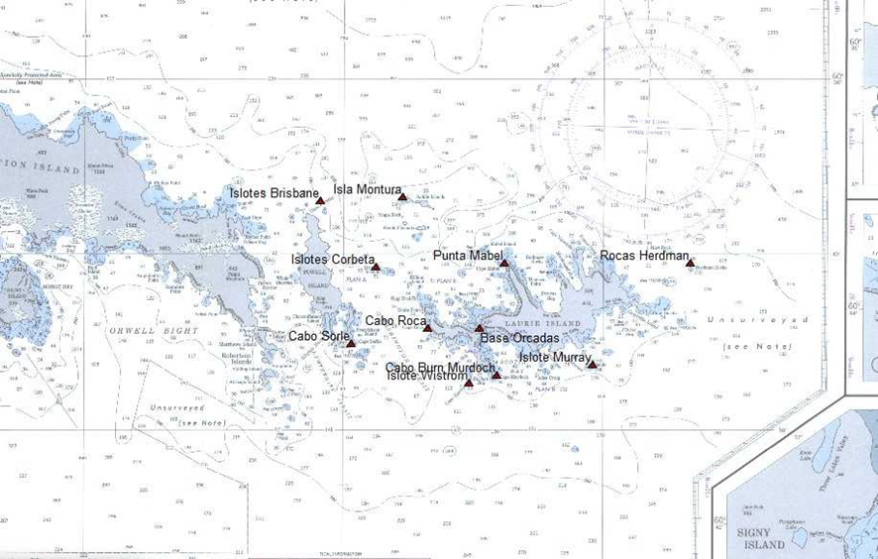

**NEW AIS AtoN EQUIPMENT, MSM TRADEMARK**

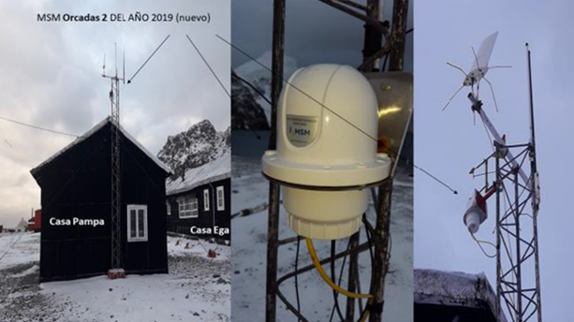

**ELECTRONIC EQUIPMENT INSTALLED AT THE MAIN BUILDING**

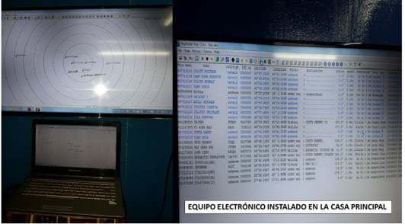

* During the 2019/2020, a new AIS AtoN was deployed at the PRIMAVERA Station (LAT.64º09’ S LON 060º 58’ W), which generates 1 real and 10 virtual signals, which were timely informed through NAVAREA VI Navigational Warnings and by the Argentine Notices to Mariners.

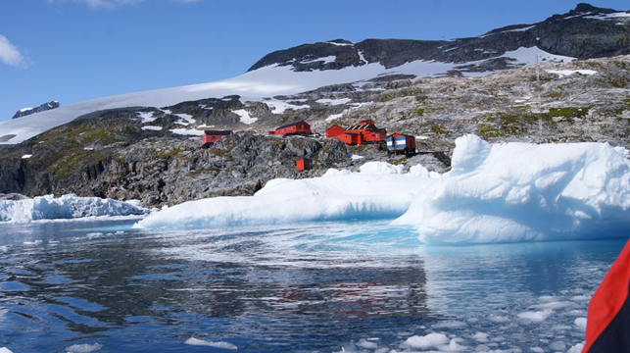

|  |  |  |  |  |  |
| --- | --- | --- | --- | --- | --- |
|  | Location | AtoN type | MMSI | Latitude | Longitude |
| 1. | **Primavera Station** | Real | 997011105. | 64°09.38’ S | 060° 57,32’ W |
| 2. | Vivot Cape | Virtual | 997016132. | 64°04.08’ S | 061º 02.12’ W |
| 3. | Kay Islet | Virtual | 997016123. | 64° 07.46’ S | 060° 55,97’ W |
| 4. | Mar Islet | Virtual | 997016122. | 64º08.61’ S | 060° 59,14’ W |
| 5. | Primavera Cape | Virtual | 997016121. | 64° 09.29’ S | 060° 57,40’ W |
| 6. | Musgo Islet | Virtual | 997016126. | 64º 09.98’ S | 061º 01.81’ W |
| 7. | José Hernández Island | Virtual | 997016137. | 64º 10.17’ S | 061º 06.41’ W |
| 8. | Pastore Islet | Virtual | 997016136. | 64º 05.55’ S | 061º 16.98’ W |
| 9. | Madariaga Islet | Virtual | 997016135. | 64º 02.92’ S | 061º16.46’ W |
| 10. | Mansilla Islet | Virtual | 997016134. | 64º 04.68’ S | 061º 01.93’ W |
| 11. | Pepino Point | Virtual | 997016133. | 64º08.42’ S | 060º 53.60’ W |

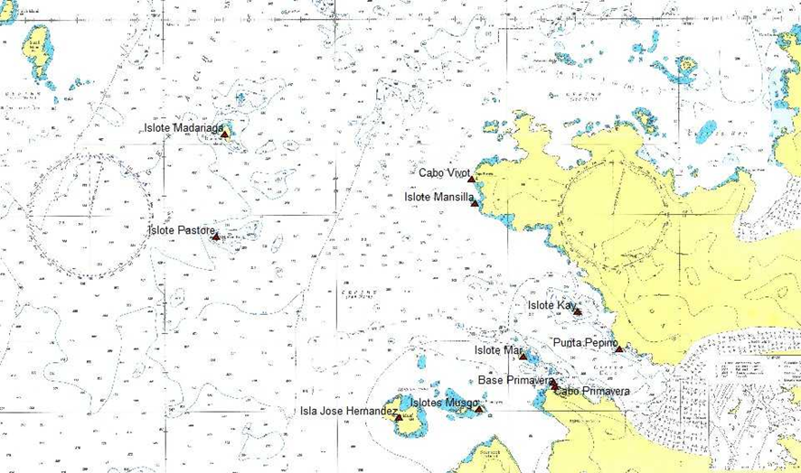

* During the 2020/2021 ASC, all the before-mentioned stations underwent maintenance works and the equipment of the ESPERANZA STATION was configured (LAT. 63° 23.5’ S LON 056° 59.4’ W) to broadcast message 8.
* During the 2021/2022 a new SIA AtoN was deployed at the PETREL Station (LAT.63º28’ S LON 056º 17’ W), which generates 1 real and 9 virtual signals, which were timely informed through NAVAREA VI Navigational Warnings and by the Argentine Notices to Mariners.

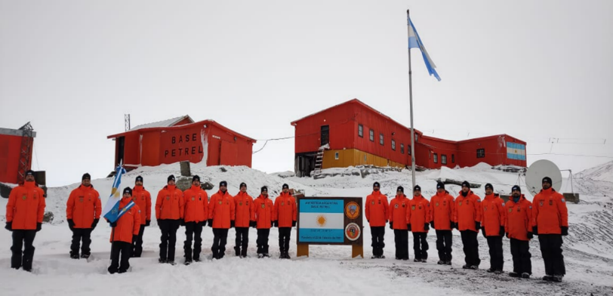

|  |  |  |  |  |  |
| --- | --- | --- | --- | --- | --- |
|  | Location | AtoN type | MMSI | Latitude | Longitude |
| 1. | **Petrel Station** | Real | 997011148. | 63°28.36’ S | 056° 13,36’ W |
| 2. | Uruguay Island | Virtual | 997016345. | 63°28.36’ S | 056° 32,02’ W |
| 3. | Rosamel Island | Virtual | 997016344. | 63° 33.43’ S | 056° 17,43’ W |
| 4. | Monte D’Urville | Virtual | 997016343. | 63°25.18’ S | 056° 18,54’ W |
| 5. | Active Rock | Virtual | 997016342. | 63° 23.27’ S | 055° 52,25’ W |
| 6. | Purvis Cape | Virtual | 997016341. | 63° 34.35’ S | 056° 01,07’ W |
| 7. | Rodriguez Cape | Virtual | 997016340. | 63° 31.47’ S | 056° 43,12’ W |
| 8. | Jonassen Rocks | Virtual | 997016339. | 63° 32.12’ S | 056° 38,43’ W |
| 9. | Scrymgeour Cape | Virtual | 997016338. | 63° 33.12’ S | 056°27.09’ W |
| 10. | Sky Beacon | Synthetic | 997011149. | 63° 28.23’ S | 056° 13,33’ W |
| 11. | Diana Reef | Virtual | 997016337. | 63°26.20’ S | 056° 12,19’ W |

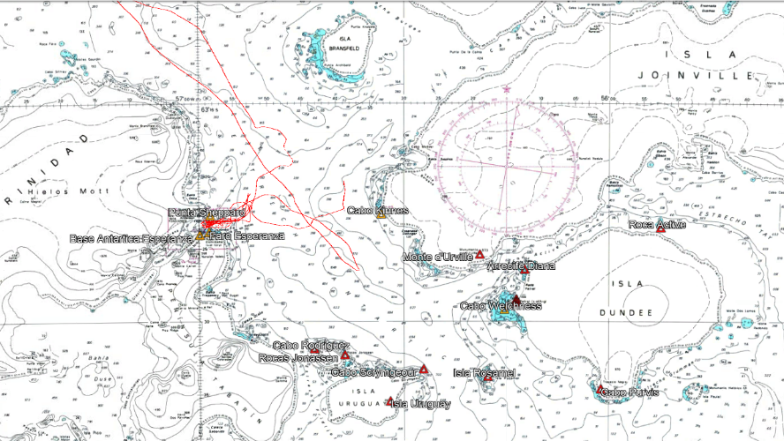

**EQUIPMENT ANTENNA INSTALLED AT THE MAIL PREMISE AT PETREL STATION**

* During the 2022/2023 ASC a new AIS AtoN was deployed at the MARAMBIO Station (LAT.64º14,4’ S LON 056º 37,7’ W), which generates one real, two virtual and four synthetic signals. These aids to navigation shall be operational in a trial mode once the MMSI be assigned.

|  |  |  |  |  |  |
| --- | --- | --- | --- | --- | --- |
|  | Location | AtoN type | MMSI | Latitude | Longitude |
| 1. | **MARAMBIO Base** | Real | Pending | 64° 14.39´ S | 056° 37,71´ W |
| 2. | Venesia | Synthetic | Pending | 64° 15.59´ S | 056° 38,39´ W |
| 3. | Chavez | Synthetic | Pending | 64° 14.08´ S | 056° 35,25´ W |
| 4. | Pierrou | Synthetic | Pending | 64° 12.92´ S | 056° 36,36´ W |
| 5. | Cincuentenario | Synthetic | Pending | 64° 21.32´ S | 056° 55,85´ W |
| 6. | Cockburn | Virtual | Pending | 64° 12.00´ S | 056° 50,53´ W |
| 7. | Gorrochategui | Virtual | Pending | 64° 12.80´ S | 056° 38,34´ W |

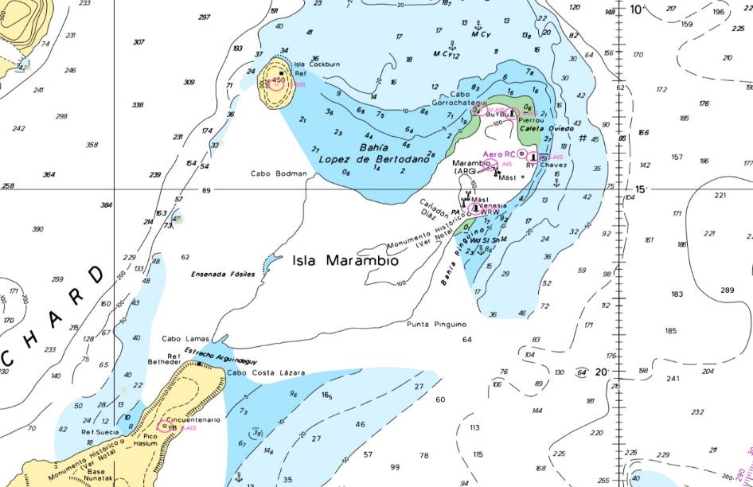

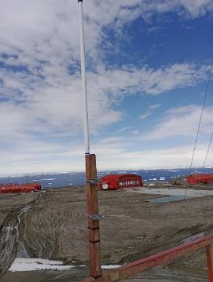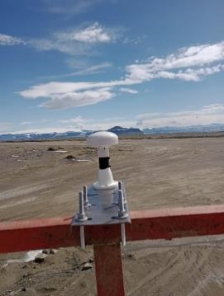**The antennas of the AIS AtoN equipments located at the control tower**

**PROPOSAL:**

The parties are hereby invited to:

1. Take note of the installation of the AIS AtoN in the Antarctic with the purpose of increasing safety in navigation for the benefit of safeguarding human life at sea and the protection of the marine environment.

2. Inform mariners and tourist operators (IAATO) that organize cruise tours to the Antarctic region about the availability of installed AIS AtoN.

3. Request mariners to inform NAVAREA VI Coordinator about operational failures of these signals or any other information that they may consider relevant for the service improvement. In order to enable communication, an online form in Spanish and English languages has been uploaded on [www.hidro.gov.ar](http://www.hidro.gov.ar).